

ENGR-UH 1000
Computer Programming for Engineers

Assignment 4 – Electrical Engineering Case Study Robot Kinematics Software Report

Gulsim Azirakhmet
Fall 2021

Step 1: Problem Identification and Statement
This assignment involves the design of a software to simulate the motion of a multi-degree of freedom kinematic chains that form the structure of a robotic system. The emphasis on geometry means that the links of the robot are modeled as rigid bodies and its joints are assumed to provide pure rotation or translation.
Step 2: Gathering of Information and Input/Output Description
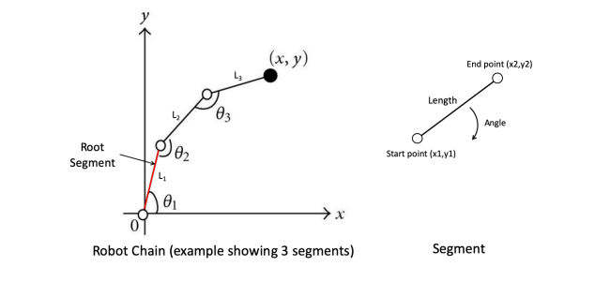
Figure 1: (left) Example of a robot chain with three segments, (right) the parameters of a segment. The system has the following components:
1. A segment: A segment is a rigid member connecting two joints. As shown in Figure 1(right), a segment has the following parameters: a starting point (x1 and y1 coordinates), a length, an angle (different technique may have different references for measuring the angle for a segment, so make your assumption clear), and an end point (x2 and y2 coordinates). Note that the coordinates of the end point can be calculated given the start point coordinates, the length, and the angle.
2. A Robot: A robot is comprised of a chain of segments that are connected via joints. The first segment is called the root as it is connected to the robot base/ground. A robot can have multiple segments, which is commonly known as the degrees of freedom. The end effector of the robot is the end point of the last segment (noted as (x,y) in Figure 1-left). In order to determine the position of the end effector, the position/orientation of all the segments must be determined – which is usually controlled through the angles of the segments. The forward kinematic analysis involves calculating the end effector position for a specific set of angles for the segments. The inverse kinematics analysis involves calculating the angles of all the segments that move the end effector to a particular position. This assignment will focus on the forward kinematics analysis.
In order to create a plot I downloaded pbPlots library. In Google I was able to find and download the library. After adding libraries and linking them, i looked up for the sample function codes to use pbPlots.

Input/Output description:
number of segments
Coordinates of the last point

angle
Graph of the segments
length

root segment length and
angle

Step 3: Design of the algorithm and hand-solved problems
Test cases:
Test Case 1: printS() function
Input:
Angle = 0.8 radians
Length=1
Output:
Length is: 1
Angle is: 0.8
Start point coordinates are (0; 0)
End point coordinates are (0.696707; 0.717356)

Test Case 2: Default() function
Please enter the number of segments
3
Enter angle of the new segment
0.7
Enter length of the new segment
5
Enter angle of the new segment
0.9
Enter length of the new segment
6
Enter angle of the new segment
1.2
Enter length of the new segment
6
Length is: 5
Angle is: 0.7
Start point coordinates are (0; 0)
End point coordinates are (3.82421; 3.22109)
Length is: 6
Angle is: 0.9
Start point coordinates are (3.82421; 3.22109)
End point coordinates are (7.55387; 7.92105)
Length is: 6
Angle is: 1.2
Start point coordinates are (7.55387; 7.92105)
End point coordinates are (9.72802; 13.5133)
The program will be set to default position
Length is 5
Angle to x axis is 0
Start point coordinates are (0; 0)
End point coordinates are (5; 0)
Length is 6
Angle to x axis is 0
Start point coordinates are (5; 0)
End point coordinates are (11; 0)
Length is 6
Angle to x axis is 0
Start point coordinates are (11; 0)
End point coordinates are (17; 0)

Test Case 3: Kinematics() function
Please enter the number of segments
3
Enter angle of the new segment
0.8
Enter length of the new segment
5
Enter angle of the new segment
0.6
Enter length of the new segment
9
Enter angle of the new segment
0.4
Enter length of the new segment
5
Please enter the values for angles that you wish to update your current angles to
0.9
1.2
1.4
Forward Kinematics has taken place
Length is 5
Angle to x axis is 0.9
Start point coordinates are (0; 0)
End point coordinates are (3.10805; 3.91663)
Length is 9
Angle to x axis is 1.2
Start point coordinates are (3.10805; 3.91663)
End point coordinates are (6.36927; 12.305)
Length is 5
Angle to x axis is 1.4
Start point coordinates are (6.36927; 12.305)
End point coordinates are (7.21911; 17.2322)

Test Case 4: draw() function

The program needs to be able to draw a plot of a created robot

Algorithm design:
main.cpp file
include “electrical engineering case_robot.h”
counter in class Point equals 0
counter in class Segment equals 0
counter in class Robot equals 0

main() function
declare numOfSegments as integer
declare S1(0.8, 1.0) as Segment class
print “How many segments do you want to start with?”, newline
read into numOfSegments
declare R1(numOfSegments) as Robot class
call printRobotInfo function for R1
call add function for R1
call printRobotInfo function for R1
call remove function for R1
call printRobotInfo function for R1
call Default function for R1
call printRobotInfo function for R1
call Kinematics function for R1
call printRobotInfo function for R1
print “Segment info: ”, newline
call prinS function for S1
call plot function for R1
electrical engineering case_point.h file
include iostream library
include cmath library
Class Point
private members
declare pointID as integer
declare x as double
declare y as double
declare counter as static integer
public members
initialize pointID with counter
initialize x as 0
initialize y as 0
increment counter
function getNumPoints
returns counter
function getX
returns x
function getY
returns y
end
electrical engineering case_segment.h file
include electrical engineering case_point.h file
Class Segment
private members
declare sID as integer
declare angle as double
declare length as double
declare ctr as static integer
declare start as Point class
declare end as Point class
declare childSegment as dynamic array
function endPoint
x1=x from function getX+(length from function getLength*cos(angle from function getAngle))
y1=y from function getY+(length from function getLength*sin(angle from function getAngle))
assign x1 and y1 as a Point class to end
public members
function Segment
initialize sID with counter
initialize angle with 0
initialize length with 0
initialize starting point's coordinates with 0
initialize end point with the function to calculate the end point
increment counter
function Segment
assign counter to sID
assign A to angle
assign L to length
assign 0 to coordinates of the starting point
assign getEnd function to end
increment counter
function getNumSegments
return counter
function getAngle
return angle
function getStart
return start
function setChildSegment
assign previousSegment to childSegment
function getChildSegment
return childSegment
function getSegmentLength
return length
Class Point function getEnd
function to calculate the end point
return end
function getStartX
return function getX from start Point class
function getStartY
return function getY from start Point class
function getEndX
return function getX from end Point class
function getEndY
return function getY from end Point class
function getStartXY
assign class Point with newX and newY values to start
function to calculate the end point
function getLength
return length
function getsID
return sID
function getCtr
return counter
function printS
print “The length is:”, function getLength, newline
print “The angle is:”, function getAngle, newline
print “The start point”,”(”, function getStartX, “;”, function getStartY, “)”, newline
print “The end point”,”(”, function getEndX, “;”, function getEndY, “)”, newline
function setAngle
assign A to angle
function to calculate the end point
function setLength
assign L to length
function to calculate the end point

electrical engineering case_robot.h file
include electrical engineering case_segment.h file
include pbPlots.hpp library
include supportLib.hpp library
Class Robot
private members
declare ID as integer
declare S as dynamic array
declare the number of segments as static integer
public members
Robot(numOfSegments)
assign realSegments + numSegments to realSegments
assign realSegments as a new size of the S dynamic array
for i<realSegment times do
declare angle and length as double
print “Please, enter the length for the new segment”, newline
read into length
while length<0 do
print “Please, enter the positive value for the length for the new segment”, newline
read into length
print “Please, enter the angle for the new segment”, newline
read into angle
while angle<0 do
print “Please, enter the positive value for the angle for the new segment”, newline
read into angle
set angle in the segment class as the entered value
set length in the segment class as the entered value
set start point coordinates in the Segment class
function add
declare addition as integer
print “Please, enter the number of segments to add”, newline
read into add
while add<0 do
print “Please, enter the positive value”, newline
read into add
assign realSegments + addition to addNumSegments
declare S1 as dynamic array
assign addNumSegments as a new size of S1 array
for i < addNumSegments do
S1[i] = S[i]
Increment i
delete array of segments S
assign addNumSegments as a new size to the dynamic array S
for i < addNumSegments do
S[i] = S1[i]
Increment i
delete array of segments S1
for i < addition do
declare angle and length as double
print “Please, enter the angle for the”, i+1, “additional segment”, newline
read into angle
while angle<0 do
print “Please, enter the positive value for the angle”, newline
read into angle
print “Please, enter the length for the”, i+1, “additional segment”, newline
read into length
while length<0 do
print “Please, enter the positive value for the length”, newline
read into length
set angle in the segment class as the entered value
set length in the segment class as the entered value
set start point coordinates in the Segment class
assign number of segments with additional segments to realSegments
function remove
declare del as integer
print “Please, enter the number of segments you would like to remove”, newline
read into del
while del<0 do
print “Please, enter the positive value”, newline
read into del
assign realSegments - del to addNumSegments
declare S1 as dynamic array
assign addNumSegments as a new size of S1 array
for i < addNumSegments do
S1[i] = S[i]
Increment i
delete array of segments S
assign addNumSegments as a new size to the dynamic array S
for i < addNumSegments do
S[i] = S1[i]
Increment i
delete array of segments S1
assign new number of segments with segments to realSegments
function Default
print “The program will be set to the default position”, newline
for i < realSegments do
set angle in the Segment class to 0
set the start coordinates in the Segment class
function Kinematics
declare angle as dynamic array
assign realSegments as a new size for the dynamic array angle
declare S1 as dynamic array
assign addNumSegments as a new size of S1 array
for i < addNumSegments do
S1[i] = S[i]
Increment i
delete array of segments S
assign addNumSegments as a new size to the dynamic array S
print “Please enter the values for angles to be updated”, newline
for i < realSegments do
read into array angle
increment i
for i < realSegments do
set angle in the segment class as the entered value
set length in the segment class as the entered value
set start point coordinates in the Segment class
increment i
delete S1 array
print “Forward Kinematics has taken place”, newline
function getNumberOfSegments
return realSegments
function printRobotInfo
for i < realSegments do
call printS function
increment i
function plot
function sample is taken from internet sources, references are given in the bibliography section

Step 4: Implementation
//***********************************************************//

//** Author: Gulsim Azirakhmet **//

//** Date Created: December 6, 2021 **//

//** Assignment 4: Robot Kinematics **//

//** UH-1000 Computer Programming for Engineers, NYUAD **//

//** Problem: **//

//** Building a Robot **//

//** Using Concepts of Forward Kinematics **//

//***********************************************************//
#include "electrical engineering case_robot.h"
int Point::ctr = 0;
int Segment::ctr = 0;
int Robot::realSegments = 0;

int main() {
int numOfSegments;
Segment S1(0.8, 1.0);
cout << "How many segments do you want to start with?" << endl;
cin >> numOfSegments;
Robot R1(numOfSegments);
R1.printRobotInfo();
R1.add();
R1.printRobotInfo();
R1.remove();
R1.printRobotInfo();
R1.Default();
R1.printRobotInfo();
R1.Kinematics();
R1.printRobotInfo();
cout << "Segment info:" << endl;
S1.printS();
R1.plot();
}

#include <iostream>
#include <cmath>//include cmath library
using namespace std;

class Point
{

private:
int pointID;//declare pointID as integer
double x;//declare x as double
double y;//declare y as double
static int ctr;//declare counter as static integer

public:
Point()
{
pointID = ctr;//initialize pointID with ctr
x = 0;//initialize x as 0
y = 0;//initialize y as 0
ctr++;//increment counter
}
Point(double X, double Y)
{
pointID = ctr;//assign counter to pointID
x = X;//assign X to x
y = Y;//assign Y to y
ctr++;//increment counter
}

static int getNumPoints()//get number of points
{
return ctr;
}
double getX()//get x
{
return x;
}
double getY()//get y
{
return y;
}
};
#include "electrical engineering case_point.h"//include point class
class Segment
{

private:
int sID;
double angle;
double length;
static int ctr;
Point start;
Point end;
Segment* childSegment;

//function for calculating end point
void endPoint()
{
double x1 = start.getX() + (getLength() * cos(getAngle()));//calculate coordnate for x
double y1 = start.getY() + (getLength() * sin(getAngle()));//calculate coordinate for y
end = Point(x1, y1);//assign end coordinates to end
}

public:

Segment()
{
sID = ctr;//initialize sID with counter
angle = 0.0;//initialize angle with 0
length = 0.0;//initialize length with 0
start = Point(0, 0);//initialize starting point's coordinates with 0
end = getEnd();//function to calculate the end point
ctr++;//increment counter
}

Segment(double A, double L)
{
sID = ctr;//assign counter to sID
angle = A;//assign A to angle
length = L;//assign L to length
start = Point(0, 0);//assign 0 coordinates to start point
end = getEnd();//assign getEnd function to end
ctr++;//increment counter
}

static int getNumSegments()//get number of segments
{
return ctr;
}

Point getStart()//get start point
{
return start;
}

double getAngle()//get angle
{
return angle;
}

void setChildSegment(Segment* previousSegment)//set child segment
{
childSegment = previousSegment;
}

Segment getChildSegment()//get child segment
{
return *childSegment;
}

double getSegmentLength()//get length
{
return length;
}

Point getEnd()//get end point
{
endPoint();//function to calculate the end point
return end;
}

double getStartX()//get start coordinate of x
{
return start.getX();
}

double getEndX()//get end coordinate of x
{
return end.getX();
}

double getStartY()//get start coordinates of y
{
return start.getY();
}

double getEndY()//get end coordinates of y
{
return end.getY();
}

void setStartXY(double newX, double newY)//get start point coordinates
{
start = Point(newX, newY);
endPoint();
}

double getLength()//get length
{
return length;
}

int getsID()//get sID
{
return sID;
}

static int getCtr()//get the counter
{
return ctr;
}

void printS()//function to print to the output screen
{
cout << "The length is: " << getLength() << endl;//print length
cout << "The angle is: " << getAngle() << endl;//print angle
cout << "The start point " << "(" << getStartX() << "; " << getStartY() << ")" << endl;//print start point
cout << "The end point " << "(" << getEndX() << "; " << getEndY() << ")" << endl;//print end point
}

void setAngle(double A)//set angle
{
angle = A;
endPoint();//calculates end point
}

void setLength(double L)//set length
{
length = L;
endPoint();//calculates end point
}

};
#include "electrical engineering case_segment.h"//include segment class
#include "pbPlots.hpp"//include plotting library
#include "supportLib.hpp"//include support library for plotting

class Robot
{

private:
int ID;//declare ID as integer
Segment* S;//dynamic array
static int realSegments;//declare the number of segments as static integer
public:
Robot(int numSegments)
{
realSegments = realSegments + numSegments;//calculate real number of segments
S = new Segment[realSegments];//assign new size to the dynamic array
for (int i = 0; i < realSegments; i++)//loop that repeats number of segment times
{
double angle, length;//declare angle and length as double
cout << "Please, enter the length for the new segment" << endl;//print message
cin >> length;//enter the answer to the length
while(length<0)//while value is negative do
{
cout << "Please, enter the positive value for the length for the new segment" << endl;//print message
cin >> length;//enter the answer to the length
}

cout << "Please, enter the angle for the new segment" << endl;//print message
cin >> angle;//enter the answer to the angle1
while (angle < 0)//while value is negative do
{
cout << "Please, enter the positive value for the angle for the new segment" << endl;//print message
cin >> angle;//enter the answer to the angle
}
S[i].setAngle(angle);//set angle in the segment class as the entered value
S[i].setLength(length);//set length in the segment class as the entered value
S[i].setStartXY(S[i - 1].getEndX(), S[i - 1].getEndY());//set start point coordinates
}
}

//function for the additional segments
void add()
{
int addition;//declare addition as integer
cout << "Please, enter the number of segments to add " << endl;//print message for additional segment numbers
cin >> addition;//read into additon
while (addition < 0)//while value is negative do
{
cout << "Please, enter the positive value" << endl;//print message
cin >> addition;//enter the answer to the addition
}
int addNumSegments = realSegments + addition;//new number of segments with added segments
Segment* S1;//dynamic array
S1 = new Segment[addNumSegments];//assign new size to the dynamic array
for (int i = 0; i < addNumSegments; i++)//loop that repeats number of segment times
{
S1[i] = S[i];//assign prevoius array of segments to new array
}
delete[] S;//delete array of segments
S = new Segment[addNumSegments];//assign new size to the dynamic array
for (int i = 0; i < addNumSegments; i++)//loop that repeats number of segment times
{
S[i] = S1[i];//assign S1 array to S array
}
delete[] S1;//delete S1 array
for (int i = 0; i < addition; i++)//loop that repeats additional number of segment times
{
double angle, length;//declare angle and length as double
cout << "Please, enter the angle for the " << i + 1 << " additional segment" << endl;//print the message
cin >> angle;//read into angle
while (angle < 0)//while value is negative do
{
cout << "Please, enter the positive value for the angle " << endl;//print message
cin >> angle;//enter the answer to the angle
}
cout << "Please, enter the length for the " << i + 1 << " additional segment" << endl;//print the message
cin >> length;//read into length
while (length < 0)//while value is negative do
{
cout << "Please, enter the positive value for the length" << endl;//print message
cin >> length;//enter the answer to the length
}
S[realSegments + i].setAngle(angle);//set angle in the segment class as the entered value
S[realSegments + i].setLength(length);//set length in the segment class as the entered value
S[realSegments + i].setStartXY(S[realSegments + i - 1].getEndX(), S[realSegments + i - 1].getEndY());//set start point coordinates
}
realSegments = addNumSegments;//assign number of segments with additional segments to realSegments
}

void remove()
{
int del;//declare del as integer
cout << "Please, enter the number of segments you would like to remove" << endl;//print message
cin >> del;//read value into del
while (del < 0)//while value is negative do
{
cout << "Please, enter the positive value" << endl;//print message
cin >> del;//enter the answer to the del
}
int addNumSegments = realSegments - del;//calculate number of segments
Segment* S1;//dynamic array
S1 = new Segment[addNumSegments];//assign new size to dynamic array
for (int i = 0; i < addNumSegments; i++)//loop that repeats number of segment times
{
S1[i] = S[i];//assign prevoius array of segments to new array
}
delete[] S;//delete array of segments
S = new Segment[addNumSegments];//assign new size to the dynamic array
for (int i = 0; i < addNumSegments; i++)//loop that repeats number of segment times
{
S[i] = S1[i];//assign S1 array to S array
}
delete[] S1;//delete S1 array
realSegments = addNumSegments;//assign new number of segments with segments to realSegments
}

//function to reset to default
void Default()
{
cout << "The program will be set to the default position" << endl;//print the message
for (int i = 0; i < realSegments; i++)//loop that repeats number of segment times
{
S[i].setAngle(0);//set angle to 0
S[i].setStartXY(S[i - 1].getEndX(), S[i - 1].getEndY());//set the start coordinates
}
}
//function to perform kinematics
void Kinematics()
{
double* angle;//dynamic array
angle = new double[realSegments];//assign new size to dynamic array
Segment* S1;//dynamic array
S1 = new Segment[realSegments];//assign new size to dynamic array
for (int i = 0; i < realSegments; i++)//loop that repeats number of segment times
{
S1[i] = S[i];//assign prevoius array of segments to new array
}
delete[] S;//delete S array
S = new Segment[realSegments];//assign new size to dynamic array
cout << "Please enter the values for angles to be updated " << endl;//print the message
for (int i = 0; i < realSegments; i++)//loop that repeats number of segment times
{
cin >> angle[i];//read into angle array
}
for (int i = 0; i < realSegments; i++)//loop that repeats number of segment times
{
S[i].setAngle(angle[i]);//set read angles
S[i].setLength(S1[i].getLength());//set length
S[i].setStartXY(S[i - 1].getEndX(), S[i - 1].getEndY());//set start point coordinates
}
delete[] S1;//delete S1 array
cout << "Forward Kinematics has taken place" << endl;//print message
}

static int getNumberOfSegments()//fumction to get a number of segments
{
return realSegments;
}

void printRobotInfo()//function to print robot info
{
for (int i = 0; i < realSegments; i++)//loop that repeats number of segment times
{
S[i].printS();//call printS
}
}
//function to plot the graph
void plot()//function sample is taken from internet sources, references are given in the lab report
{
vector<double> xs;
vector<double> ys;
for (int i = 0; i < realSegments; i++)
{
xs.push_back(S[i].getStartX());
xs.push_back(S[i].getEndX());
ys.push_back(S[i].getStartY());
ys.push_back(S[i].getEndY());
}
bool success;
StringReference* errorMessage = new StringReference();
RGBABitmapImageReference* imageReference = CreateRGBABitmapImageReference();
success = DrawScatterPlot(imageReference, 600, 400, &xs, &ys, errorMessage);
if (success)
{
vector<double>* pngdata = ConvertToPNG(imageReference->image);
WriteToFile(pngdata, "example1.png");
DeleteImage(imageReference->image);
}
else
{
cerr << "Error: ";
for (wchar_t c : *errorMessage->string)
{
wcerr << c;
}
cerr << endl;
}
}
};

Step 5: Software Testing and Verification

Test Case 1: printS() function
Output:
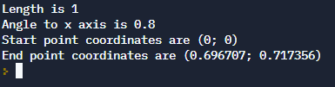

Test Case 2: Default() function
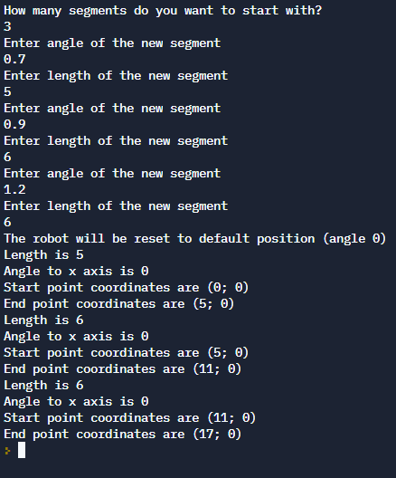
Test Case 3: Kinematics() function
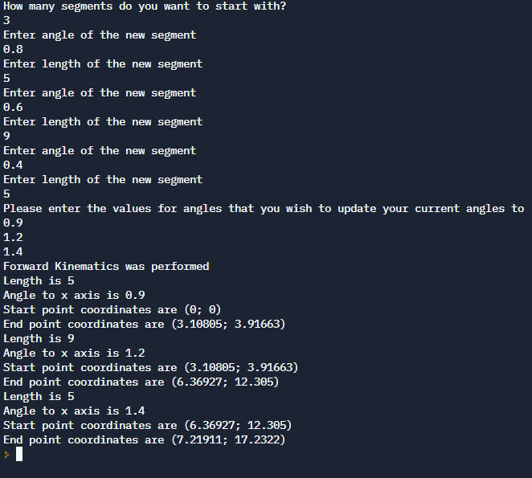
Test Case 4: plot() function
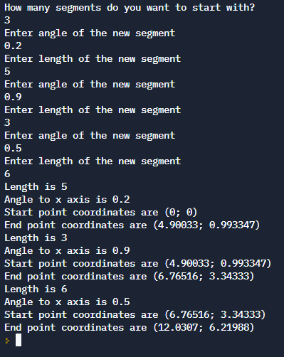
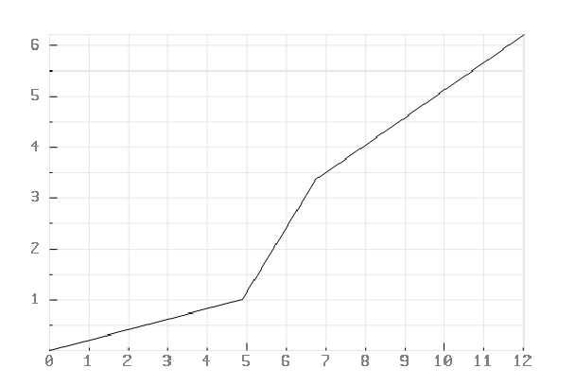

All the data in the test cases are logical and are in agreement with the expectations
User’s Guide
This program will help you to identify the coordinates of the last point of the robot’s segment. You will be asked to enter the angle and length for the each segment of the robot. You may add or remove the segments of the robot. Program will show you the coordinated of the last point and plot a graph of the robot’s segments. Program has functions to set the point to the default position to set angles to 0 and kinematics function to change angles.

Bibliography

“An easy way to plot in a Visual Studio 2019 C++ program, ” Microsoft Q&A, September 27, 2021, https://docs.microsoft.com/en-us/answers/questions/567439/an-easy-way-to-plot-in-a-visual-studio-2019-c-prog.html.

